1. [**https://www.makeup.com.ua/**](https://www.makeup.com.ua/)

Request method: GET means to retrieve information from a given server using a given URI. Status response code: 301 (“moved permanently”) - redirection means that the requested resource has been permanently moved to a new location. 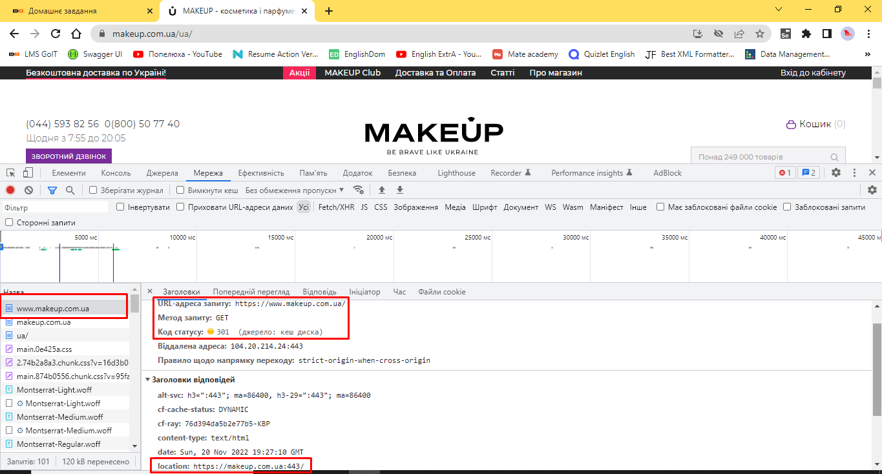

The address of the new location of the resource is indicated in the Location field - <https://makeup.com.ua:443/>

1. [**https://makeup.com.ua/**](https://makeup.com.ua/)

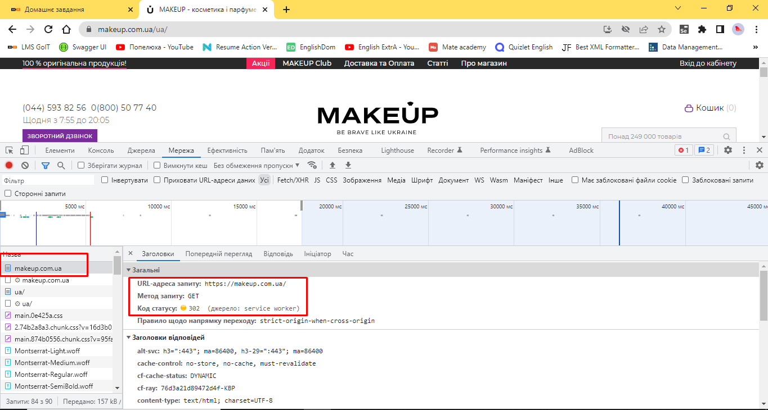

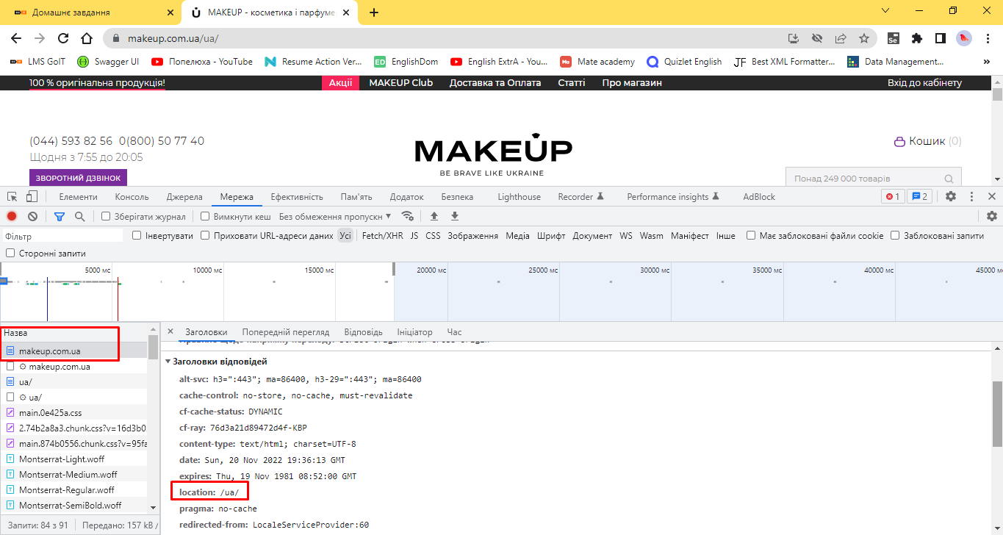

Request method: GET means to retrieve information from a given server using a given URI.

Status response code: 302 (“temporarily moved”) - redirection means that the resource is temporarily located under another URL. The address of the location of the resource is indicated in the Location field - /ua/

1. **Cart**

* **Adding a product to the cart**

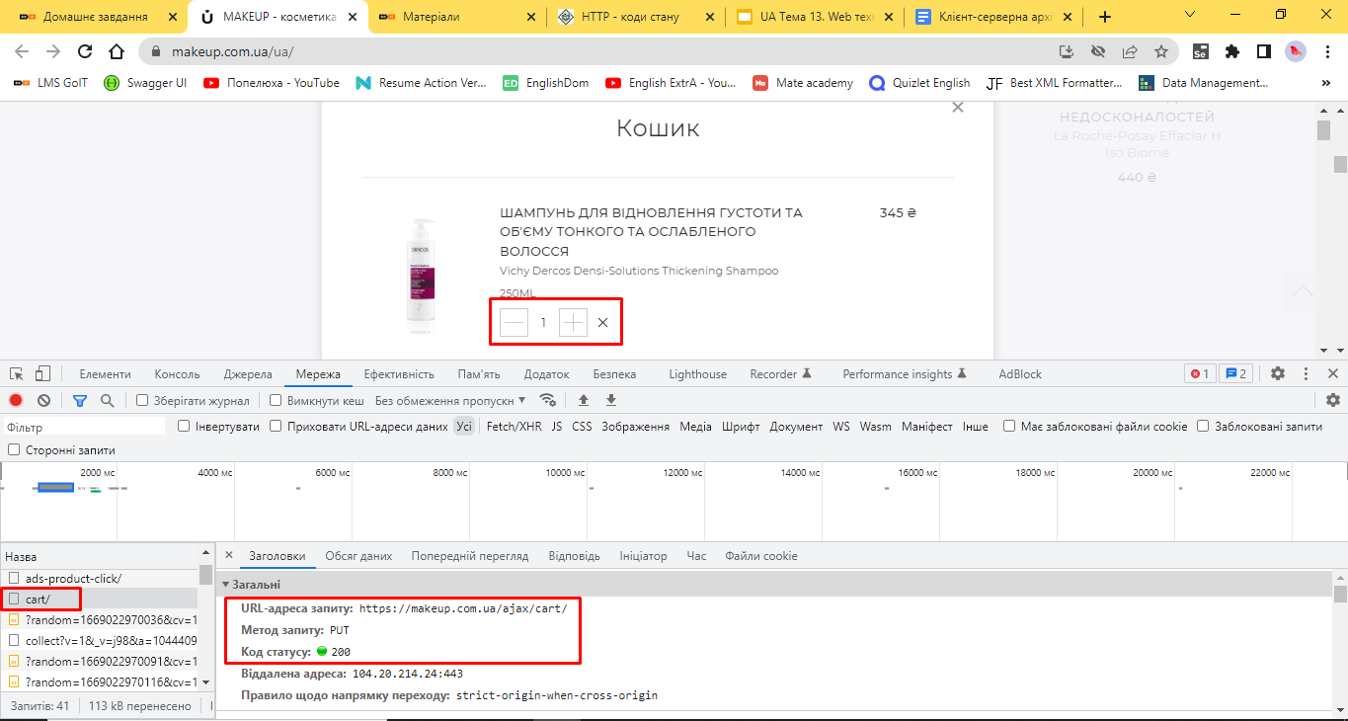

Request method: PUT is used to update, and change already existing objects.

Status response code: 200 means that the request was completed successfully.

* **Increasing the number of items in the cart from 1 to 2**

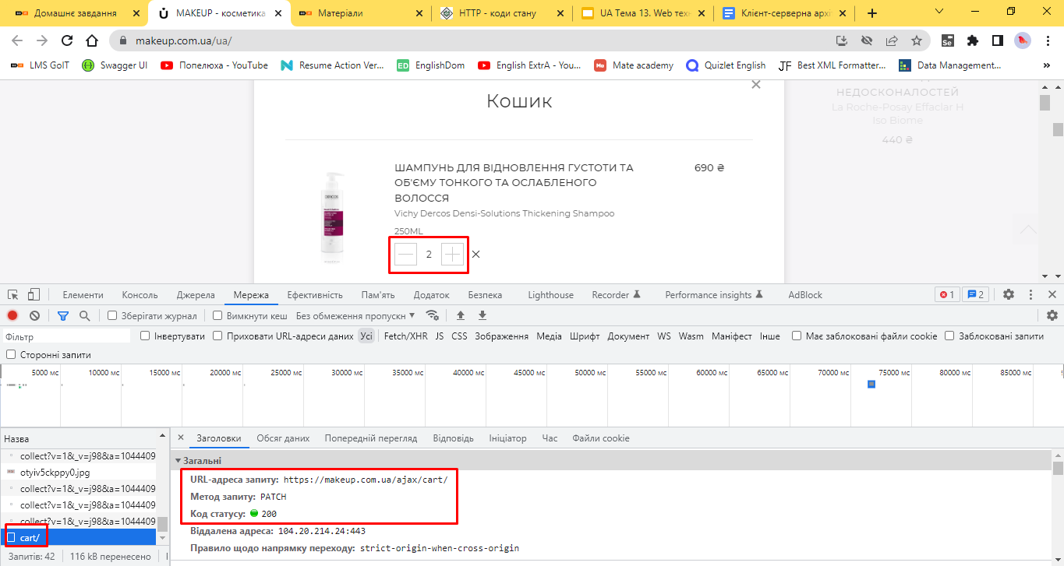

Request Method: PATCH stands for Partial Resource Change.

Status response code: 200 means that the request was completed successfully.

* **Deleting the product from the cart**

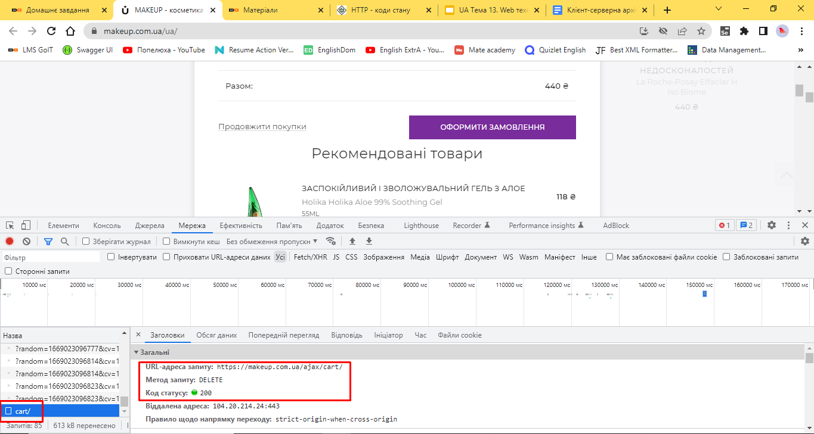

Request Method: DELETE is used to delete a resource identified by a URI.

Status response code: 200 means that the request was completed successfully.

1. [**https://www.makeup.ua/**](https://www.makeup.ua/)

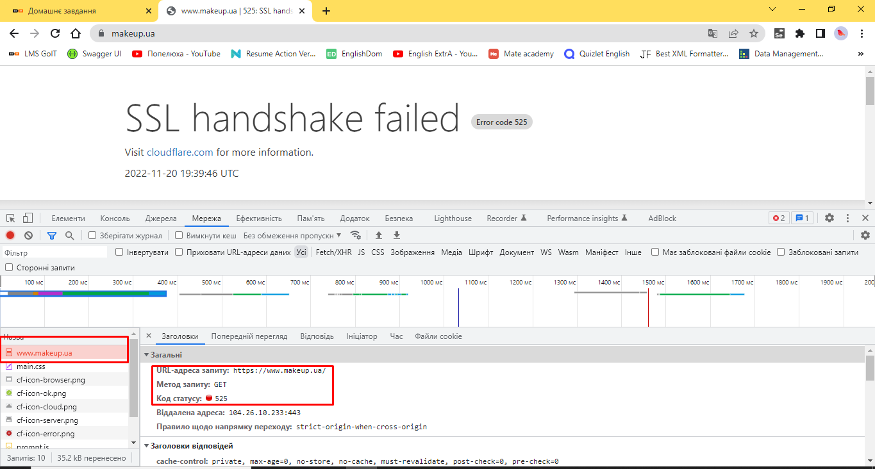

Request method: GET means to retrieve information from a given server using a given URI.

Status response code: 525 is a non-standard CloudFlare code, meaning an SSL handshake error between the CDN server and the web server.